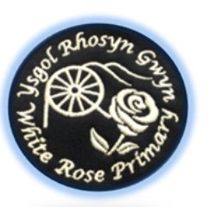
Croeso i
Dosbarth Gwyrdd

Mrs Doyle - I have been working at White Rose Primary School for 21 years. I lead Science & Technology AOLE throughout the school and I love STEM especially Faraday Friday. I have two children Poppy and Milo who also came to this school. I enjoy running and spending time with my family and new kittens called Chaney.
Miss Morgan–My name is Miss Morgan and I am so excited to be your TA this year. I’ve worked at White Rose for 11 years as a ALN 1-1 and as a TA. I like reading and listening to music. I have a dog called Gizmo. I can’t wait for all the fun and exciting things we will be experiencing together this year.

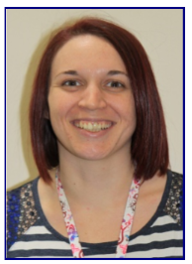
Brief topic overview for Autumn term
Big Question: Do all heroes wear uniforms?
We will be focusing upon ‘. The weekly activities will be initiated by them. We plan and develop ideas and experiences through pupil voice and observations. Pupils will learn through play, play based learning, being outdoors, and experiences through authentic and purposeful learning.
All information will be shared via class dojo.
Dosbarth Melyn is located on the ground floor opposite the hall door. Pupils are collected from the furthest fenced in area. Please could you notify either myself on dojo or the office if someone new is collecting your child? Messages will not be read on dojo during the school day.
PE will take place on …… Pupils will need to bring their kits into school in a bag.
Navy or dark shorts, white T shirt & trainers.
Equipment your child will need:
Reading book to be returned on a weekly basis
Reading bag.
Warm coat in the winter
Water bottle
Wellies with their names written inside with a peg to attached to them.
All clothing will require your child’s name.

