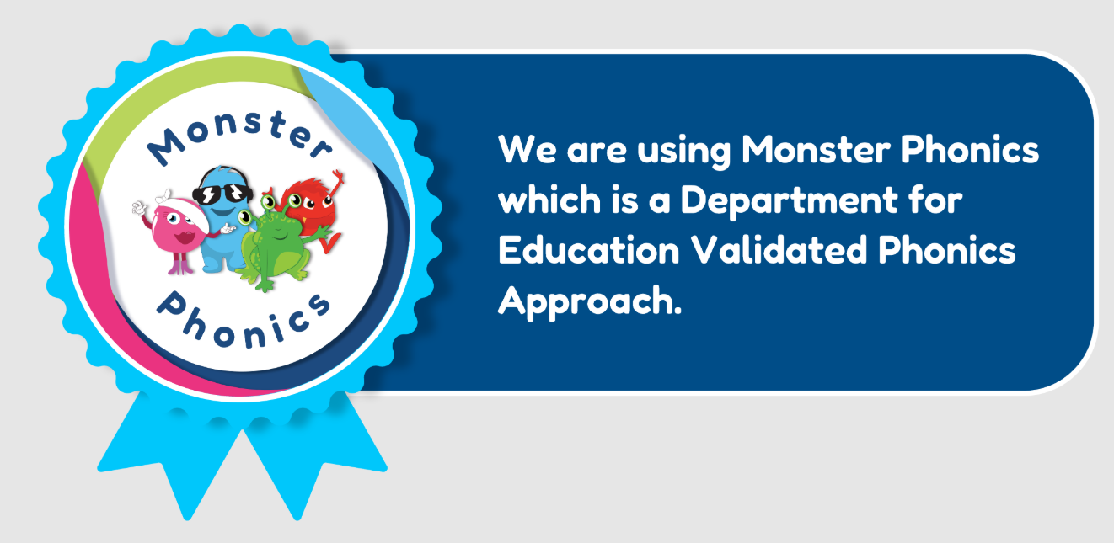

Supporting Early Reading with Monster Phonics
At White Rose Primary we are committed to helping every child become a confident, fluent reader. To support this, we use Monster Phonics – a systematic synthetic phonics programme that makes learning to read engaging, accessible and effective for all children.
Validated by the UK Department for Education and aligned with the Curriculum for Wales, Monster Phonics uses colour coding and memorable characters to help children learn phonics quickly and confidently. Through structured daily lessons, children build the skills they need to become successful readers for life.

Why Reading Matters
Learning to read is one of the most important skills a child will ever develop.
Strong reading skills help children to:
- Access all areas of the curriculum.
- Build confidence and independence.
- Develop vocabulary, communication and imagination.
- Enjoy reading for pleasure throughout their lives.

How Monster Phonics Helps Children Learn to Read
Monster Phonics teaches children to read in a clear, step-by-step way.
Children learn to:
- Recognise the sounds that letters and letter combinations make.
- Blend sounds together to read words.
- Read with increasing accuracy, confidence and fluency.
- Apply their phonics knowledge when spelling and writing.
The programme follows a carefully planned sequence, introducing new sounds and spelling patterns at the right time so that every child can build on what they already know.

Reading Books That Match Your Child's Learning
Monster Phonics provides a wide range of fully decodable reading books that are carefully matched to the phonics your child has already been taught.
These books are used in guided reading sessions, giving children regular opportunities to practise and apply their developing reading skills.
By reading books that closely match their phonics knowledge, children can:
- Read words using the sounds and spelling patterns they have already learned.
- Build confidence through repeated success.
- Develop reading fluency and accuracy.
- Become independent readers by decoding words rather than relying on pictures or guessing unfamiliar words.
As children learn more phonics, they move through progressively more challenging books, building the knowledge and confidence needed to become fluent readers.

Supporting Reading at Home
You can make a huge difference to your child's reading by spending just a few minutes each day reading together. Regular reading, practising phonics sounds and talking about books all help to build confidence and fluency.
To find out more about how Monster Phonics teaches reading and discover practical tips for supporting your child, visit the Monster Phonics Parent Information page:
https://monsterphonics.com/phonics-support-for-parents/
We look forward to working in partnership with you to help your child develop a lifelong love of reading.

